A Mutual Enemy

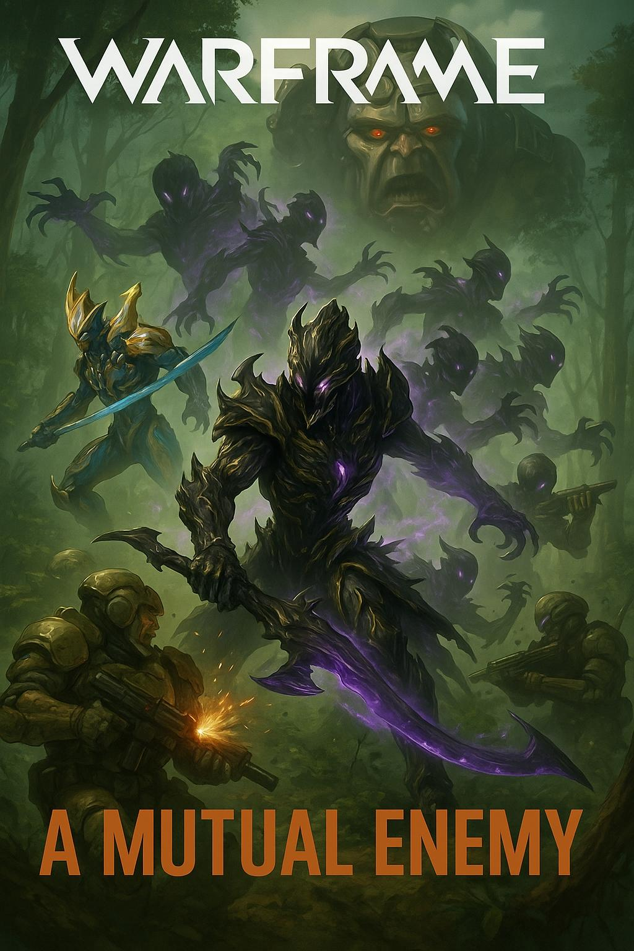

**A Mutual Enemy**

**Mission Launch: 5/4/2025**

**1. Rescue – Pacific**  
Codename: “The Keyholder”  
A former Grineer logistics officer defected after uncovering a transmission detailing when the stolen weapons data would be uploaded to a secure relay. Now imprisoned deep within a Pacific forest garrison, the officer is due for interrogation and termination. Vay Hek, begrudgingly unable to retrieve the asset himself without exposing internal weakness, tasks the Tenno with extracting the informant. “Get in, get out—don’t think this makes us allies, Tenno,” he sneers. Steel Path reinforcements tighten their grip every moment the Tenno delays.

**2. Spy – Cambria**  
Codename: “Echoes in the Vents”  
The decrypted intel from Pacific points to Cambria—an old terraforming site turned clandestine data nexus. Here, deep within derelict corridors, Grineer engineers are storing schematics and coordinates for the stolen weapon stockpile. Vay Hek wants the location obliterated from their systems, but you, Tenno, must first infiltrate, extract the data, and disappear without setting off the alarms. “Touch nothing else—your curiosity is as dangerous as your arrogance,” Hek barks, as enemy patrols sweep for intruders in the heightened Steel Path security grid.

**3. Sabotage – Cervantes**  
Codename: “Ashes of Ambition”  
Deep within Cervantes, the Grineer have begun manufacturing a prototype weapon derived from stolen Parvos tech—designed specifically to counteract Tenno warframes and Vay Hek’s terraforming armor. The facility is powered by overgrown biofuel generators and shielded reactors, hidden beneath the forest canopy. Vay Hek demands its destruction to preserve his own supremacy, though he makes it clear he expects no survivors. “Burn it all to cinders, Tenno—but leave the wreckage as a warning. I want them to know who let you off the leash.” With Steel Path resistance crawling across every path, only the most prepared Tenno will survive this scorched-earth conclusion.

Perfect addition.

### **Mission Reward: Volatile Orgis Skin**

Upon successful completion of the “A Mutual Enemy” mission chain in Steel Path mode, the Tenno are granted the **Volatile Orgis Skin**—a volatile, Grineer-enhanced aesthetic for the Orgis launcher. Forged from fragments of the destroyed weapons facility and laced with volatile chemicals once meant to counter Tenno technology, this skin pulses with unstable energy and scorched plating.

**Skin Highlights:**

* **Visuals:** Ember-glowing vents, exposed chemical pipes, and reinforced Grineer casing with hazard-stripe accents.
* **Effect:** Custom explosion visuals with searing orange and toxic green detonations.
* **Lore:** A reluctant trophy sanctioned by Vay Hek himself—“Consider this my... gratitude. Gah! I can’t believe I said that…”

***House of Mason Publishing ©️2025***