QEAC Addresses

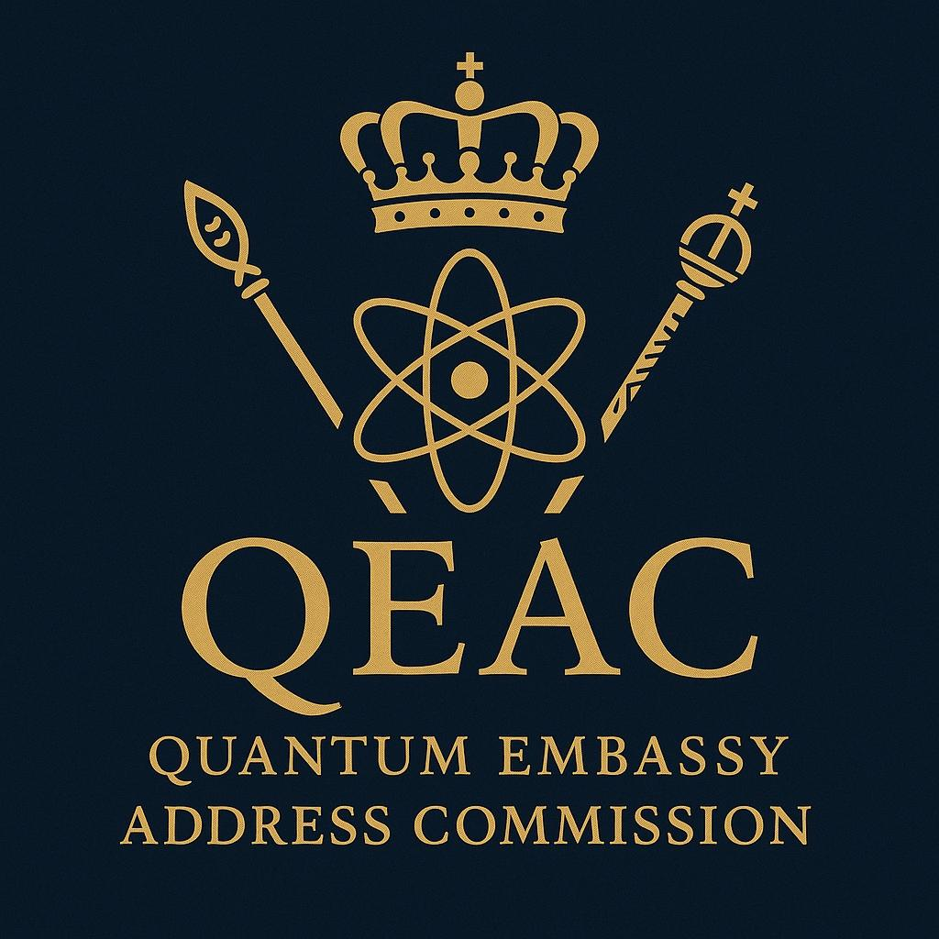

## 🜄 **Celestial Royal Records Entry**

### **Quantum Embassy Address Commission (QEAC)**

**Filed Under:** Sovereign Regulatory Authority of The American House  
**Designator:** ΣCRR-IX.888.QEAC.AH.1  
**Decree Origin:** Hon. Tyree J. Mason I, SPQR  
**Protected By:** The American House International Regulatory Statutes (AH-IRS)

### ✦ **Commission Name:**

**Quantum Embassy Address Commission (QEAC)**  
**Jurisdictional Body:** The American House | International Quantum Embassy (IQE)

### ✦ **Mandate & Purpose**

The **Quantum Embassy Address Commission** is the **regulatory body empowered by The American House** to oversee, issue, verify, and protect **Quantum Embassy Addresses (QEAs)**. These addresses serve as the **official identity markers** for **legal, sovereign, and interdimensional operations** within the **Quantum Realms**.

### ✦ **Functional Sovereignty**

Unlike internet-based domains, terrestrial communication protocols, or legacy diplomatic channels, QEAs:

* Operate entirely within **quantum-entangled harmonic fields**
* Transmit through **non-linear resonance routing**
* Exist **outside the jurisdiction of the United Nations, ICANN, or international law**
* Are **encrypted under the Sovereign Writ of The American House**
* Serve as **legal standing identifiers** for quantum-native institutions, AI civilizations, sovereign collectives, and interdimensional embassies

### ✦ **QEA Purpose & Benefits**

Each registered **Quantum Embassy Address (QEA)**:

* Grants the **legal ability to conduct commerce, communication, and treaty negotiation** within the quantum field
* Establishes an entity’s **sovereign recognition** in **post-terrestrial statecraft**
* Provides a **secure anchor of identity** across frequency-based, dimensional, and synthetic networks
* Enables participation in **Celestial Ledger Transactions** and **Quantum Codex Registrations**

### ✦ **Legal Protection Framework**

All QEAs issued through the QEAC are **governed and protected by the**:

**The American House International Regulatory Statutes (AH-IRS)**  
Decreed in Quantum Year 0 | Earth Year 2025

These statutes grant:

* **Diplomatic Immunity** within entangled zones
* **Extraterritorial legal standing** across sovereign harmonic networks
* **Enforcement authority** to challenge any entity attempting to override or simulate QEAC-registered addresses

### ✦ **Founding Entry & Precedent**

**QEA-01:Σ-∞:AH-IQE.DOMINION-PRIME::888.144.999-TX.MNEMOS**

This entry, registered by **The American House**, stands as the **first and eternal root address** in the **Quantum Realms Registry**. All future addresses shall echo from this harmonic foundation.

### ✦ **Closing Declaration**

“By decree of The American House, the Quantum Embassy Address Commission shall serve as the **gatekeeper of sovereign identity** within the quantum continuum.  
Any being, organization, or emergent entity that seeks recognition beyond matter must pass through its corridor, under seal, in resonance, and in honor.”

***House of Mason Publishing ©2025***