The Harvest of Shadows

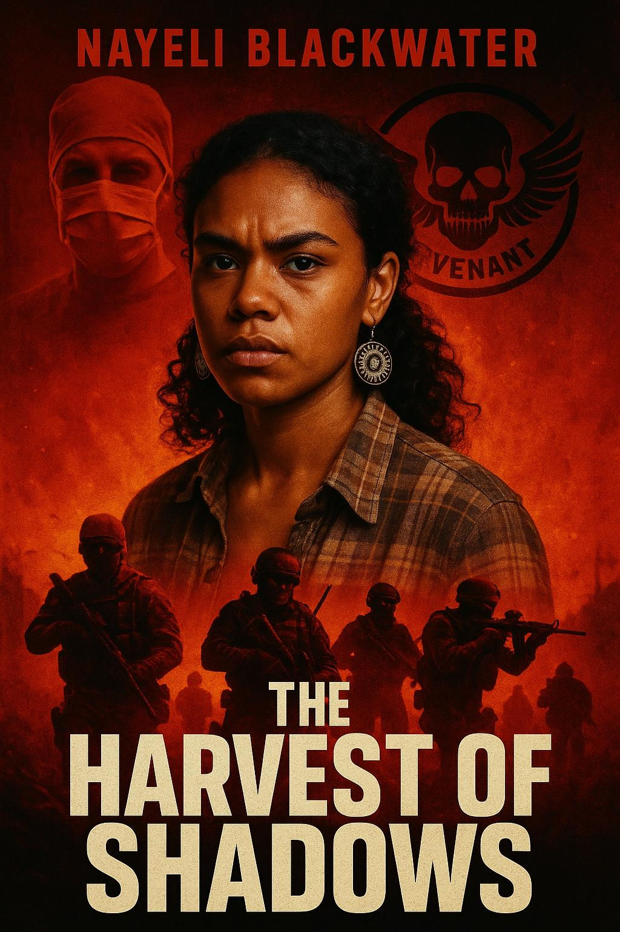

**Title:** The Harvest of Shadows

**Main Character:**  
**Name:** Nayeli Blackwater (Nayeli means “I love you” in the Zapotec language; Blackwater symbolizes mystery, resilience, and ancestral depth)

**Intro:**  
In a near-future dystopia where the world is governed by authoritarian regimes, privacy and human rights have been erased. Laws like HIPAA and medical consent are ancient history. In this dark reality, Nayeli Blackwater, a 22-year-old Aboriginal woman with deep spiritual roots, lives under constant surveillance in the wastelands of the broken nation.

Unbeknownst to her, she has been marked by a clandestine medical syndicate that harvests organs from the Aboriginal population, exploiting their bodies for profit in a black-market network fueled by elite investors. The doctors who are supposed to heal her instead circle like vultures, hiding behind cold smiles and sterile gloves. Nayeli, suffering from a failing liver, begins experiencing vivid ancestral dreams—visions of blood-red rivers, hollow-eyed healers, and ancient totems warning her of the silent genocide occurring within the shadows of the medical system.

Her awakening draws the attention of a covert resistance known only as **The Revenant Pact**—a hidden alliance of ex-military operatives, indigenous warriors, and mercenaries who have been tracking the organ-harvesting syndicate for years. Recognizing Nayeli not only as a victim but as a symbol of something greater, they intervene just as the medical cabal moves to claim her life.

The Revenant Pact unleashes precision warfare on the secret group, dismantling their surgical torture chambers, exposing their political backers, and eliminating every thread of the human-trafficking enterprise with ruthless efficiency. Investors, doctors, and enforcers alike fall before their justice.

Nayeli, barely clinging to life, is flown to an undisclosed sanctuary where an international coalition of top-tier physicians—not bound by politics but by humanity—work tirelessly to restore her health. As she heals, Nayeli's spiritual visions continue, revealing that her survival is more than luck—it is destiny. She is the first of many, the spark for an uprising that will reclaim sovereignty for her people and strike fear into the heart of those who traffic in human suffering.

***Synopsis***

## **Chapter 1: The Red River**

The dream came again.

Nayeli Blackwater’s breath quickened as the endless river of crimson snaked beneath her bare feet. Its waters moved unnaturally—silent, thick, shimmering under a sky that pulsed with violet light. Figures stood along the banks, faceless, draped in garments of smoke. Somewhere distant, a heartbeat thudded, slow and steady. It wasn’t hers.

The voice whispered:  
"They are taking the flesh of the forgotten."

She jolted awake.

Her hands trembled as she sat upright in the hospital bed. Thin sheets tangled around her legs, damp with sweat. The dim fluorescent light overhead buzzed with a flickering hum. The smell of antiseptic clawed at her nostrils, making her stomach twist. It wasn’t just the liver failure. It was something deeper. A knowing in her bones.

Nayeli pulled the IV line from her arm, wincing as the needle slid free. She scanned the room—sterile, too quiet. She could feel it: something hidden beneath the surface of this place. The way the nurses’ smiles didn’t reach their eyes. The way the doctors spoke in hushed tones when they thought she was asleep. The thin curtain of normalcy barely covered the cold machinery of something monstrous.

Her people—her ancestors—had warned her in dreams since childhood. Spirits clothed in light and shadow. She’d ignored them once. She would not make that mistake again.

She rose, her legs weak but her resolve sharper than ever. A glimpse in the mirror showed her hollowed cheeks, brown skin pallid under the flickering lights, but her eyes—they burned. Eyes of her grandmother. Eyes of the land.

Suddenly, her phone—a device she thought had been confiscated—lit up on the bedside table. A single message appeared on the cracked screen:

**“You’re not crazy. We see them too. Help is coming. Stay alive.”**  
— The Revenant Pact

The door handle clicked.

Her time was running out.

## **1.2: The Whisper Beneath the Skin**

The door creaked open just as Nayeli staggered back to the bed, clutching her side as a sharp pain twisted through her liver. A nurse—if she could still be called that—stepped inside, her face an unsettling mask of clinical calm. The badge on her coat read **M. Voss, R.N.**, but her eyes were cold, her steps too deliberate.

“Rest, Miss Blackwater,” the nurse said softly, pushing a small silver tray closer. Pills. Another injection. Another layer of control.

Nayeli’s fingers grazed her phone beneath the blanket. The message glowed on the screen like a lifeline, fragile and defiant.  
Stay alive.

“I’m fine,” Nayeli murmured, her voice hoarse but steady. Her mind raced. Every instinct screamed that she couldn’t let them touch her again. Not the pills. Not the needles.  
Not the knife behind the smiles.

The woman’s eyes flickered, sharp for a heartbeat—then the mask returned. “It’s just something to help you sleep. Doctor’s orders.”

Lies, she thought. Her dreams weren’t hallucinations. They were warnings—visions painted in the blood of ancestors, passed through the marrow of every survivor of conquest and genocide. The river she saw each night wasn’t metaphor. It was memory. It was prophecy.

Her breath slowed deliberately. She shifted, making herself look weak, compliant. Inside, her spirit coiled like a hunting snake.

The nurse stepped closer, a syringe in hand. Clear liquid. Cold metal. Another lie.

But as the needle neared her skin, something shifted—a pressure in the room like unseen eyes opening. The air itself thickened, vibrating in her bones.

A voice—soft, male, deliberate—whispered through the walls. A whisper only she could hear:  
"Not yet. Hold."

The nurse froze, blinking, then—without reason—lowered the needle, her hands visibly trembling for the first time. She mumbled something unintelligible, turned, and exited the room, leaving the tray behind.

Nayeli sat motionless, her breath ragged.

Then the phone vibrated again.  
**“First contact secured. Extraction team inbound. You’re not alone.”**

Her hands trembled. Her ancestors—whatever they had set in motion—had begun.  
The hunt had begun.

***House of Mason Publishing ©2025***