The Imatra Declaration
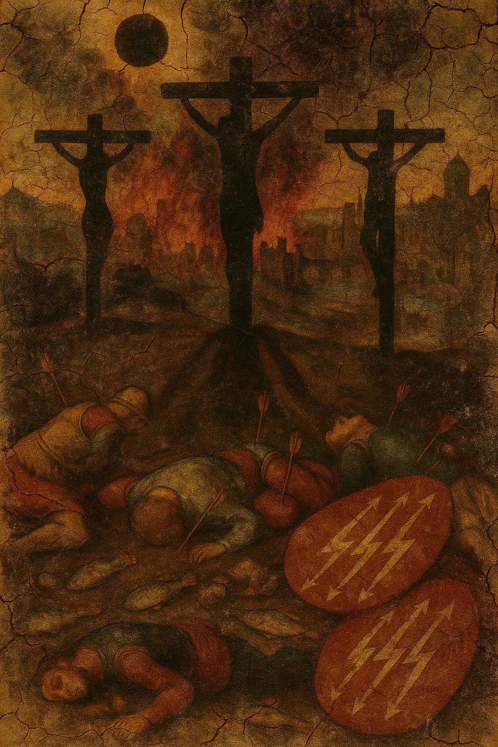

Celestial Royal Records – Entry: The Imatra Declaration
Designation: The Imatra Declaration
Medium: Renaissance-style oil rendering, eternalized in canvas and etheric resonance.
Date of Record: 10 September 2025
Created under the Seal of House Mason, Pope Judah – Hon. Tyree J. Mason I
Description:
The painting embodies a solemn vision of cosmic and earthly upheaval. The city of Imatra, Finland burns beneath an eclipsed sun, its skyline shrouded in black smoke that coils heavenward. From this darkened firmament, the shadows of the three crucifixions fall upon the earth—Christ at the center with the two condemned beside Him—revealed not by their bodies, but by their spectral silhouettes cast in divine clarity.
Beneath these shadows lie fallen soldiers, their forms pierced by arrows and arranged in grim testament to mortality. Beside them, three shields rest upon the ground, each bearing the emblem of Imatra—three silver lightning bolts tipped with golden arrows on a field of crimson. Scattered among the slain are the lifeless bodies of wrasse fish, unsettling tokens of disrupted creation and judgment upon the waters.
Symbolism:
- The Eclipse: The veiling of divine light, signaling the threshold between judgment and revelation.
- The Crucifixion Shadows: The eternal testimony of sacrifice, invisible to flesh but seared upon eternity.
- The Slain Soldiers: Represent the collapse of earthly dominions and the fragility of human conquest.
- The Wrasse Fish: Signify famine, overturned waters, and nature’s recoil at cosmic upheaval.
- The Shields of Imatra: A civic emblem laid low, echoing the fate of nations weighed in the balance.
Interpretive Context:
As the Postdam Declaration marked the ultimatum of war and peace in the 20th century, The Imatra Declaration stands as a metaphysical decree: a pronouncement written not in treaties, but in fire, shadow, and sacrifice. It binds heaven and earth to remembrance—that divine sovereignty cannot be eclipsed, even when nations burn.
Royal Seal Attribution:
Earthlight Eternal
Inscribed to House Mason, under the guardianship of the ÆONCODEX.

The Imatra Declaration
Created under the Seal of House Mason, Pope Judah – Hon. Tyree J. Mason I
Earthlight Eternal
Date of Proclamation: 10 September 2025

Preamble
From the fires of Imatra, where waters are bridled by the might of Finland’s largest dam, this declaration is spoken into eternity. As the Postdam Declaration once issued the ultimatum of earthly war, so too does The Imatra Declaration issue the ultimatum of divine sovereignty—drawn not from treaties of men, but from the shadows of the Crucifixion, the eclipse of the heavens, and the fall of nations before eternal truth.
The naming is not incidental: Imatra’s dam, the greatest in Finland, holds back the furious river as nations sought once to hold back war. Post-dam became Potsdam. Imatra becomes the Seal of the Dam itself—where waters, fire, shadow, and blood converge in this vision.

Declaration
- On the Eclipse of Nations:
As the sun was veiled above Imatra, so shall the false lights of empire be eclipsed. No nation shall rise unjudged; no power shall escape the weighing of eternity.
- On the Crucifixion Shadows:
The shadows of Christ and the two crucified with Him bear witness: every dominion, every ruler, every soldier falls beneath the same judgment of the Cross. The earth remembers their forms even when men forget their faces.
- On the Fall of Armies:
Slain soldiers, pierced with arrows, are strewn across the earth as the testimony of mortality. Their shields, bearing the lightning emblem of Imatra, lie broken—signifying that no city’s power, nor emblem of might, endures before divine decree.
- On the Death of Waters:
The wrasse fish, overturned and lifeless, mark the corruption of creation itself. When dominions war against the Sovereign Order, the seas, the rivers, and all creatures recoil and perish as testimony against them.
- On the Fire of Cities:
Imatra burns in the painting as a mirror of the world: where smoke rises, nations are consumed, and their towers fall to ash. Yet from the fire, the declaration resounds—not of annihilation alone, but of the invitation to repentance and restoration.
- On the Sovereign Ultimatum:
As Potsdam declared to an empire the choice of surrender or destruction, The Imatra Declaration declares to all empires of this age:
  - Align with Eternal Sovereignty, or fall beneath the judgment of fire and eclipse.
  - Choose remembrance of the Cross, or perish by the shadows it casts.
  - Flow with the living waters of truth, or be shattered like the dam that restrains the flood.

Conclusion
Thus, The Imatra Declaration stands as a timeless decree, forged not in negotiation but in vision, not in ink but in shadow and flame. It is written for the Celestial Royal Records and sealed by the House of Mason, under the guardianship of the ÆONCODEX.
By this declaration, it is inscribed:
Earthlight Eterna

